
English Task

Y9 HOME LEARNING PACK

Students have been lucky enough to be invited to enter three Young Writer competitions, with prizes to be won and winning entries published into a collection of story and poetry anthologies.
Below, you will find the required tasks and information on how to complete each entry.
Missing – write your own thrilling mini saga about the given theme. Tension and suspense should have your reader’s gripped! However, your story can only be one-hundred words long. Ideas are included on the entry form to help you create an engaging piece of writing.
Spine Chillers – use tension, suspense and atmosphere to grip the reader. An example story is on the entry form to help you with ideas. Like the Missing story, you only have one hundred words to wow your reader.
Through Their Eyes – write a poem about anything you like, there is no limit! Find tasks on the entry form to help you create ideas.
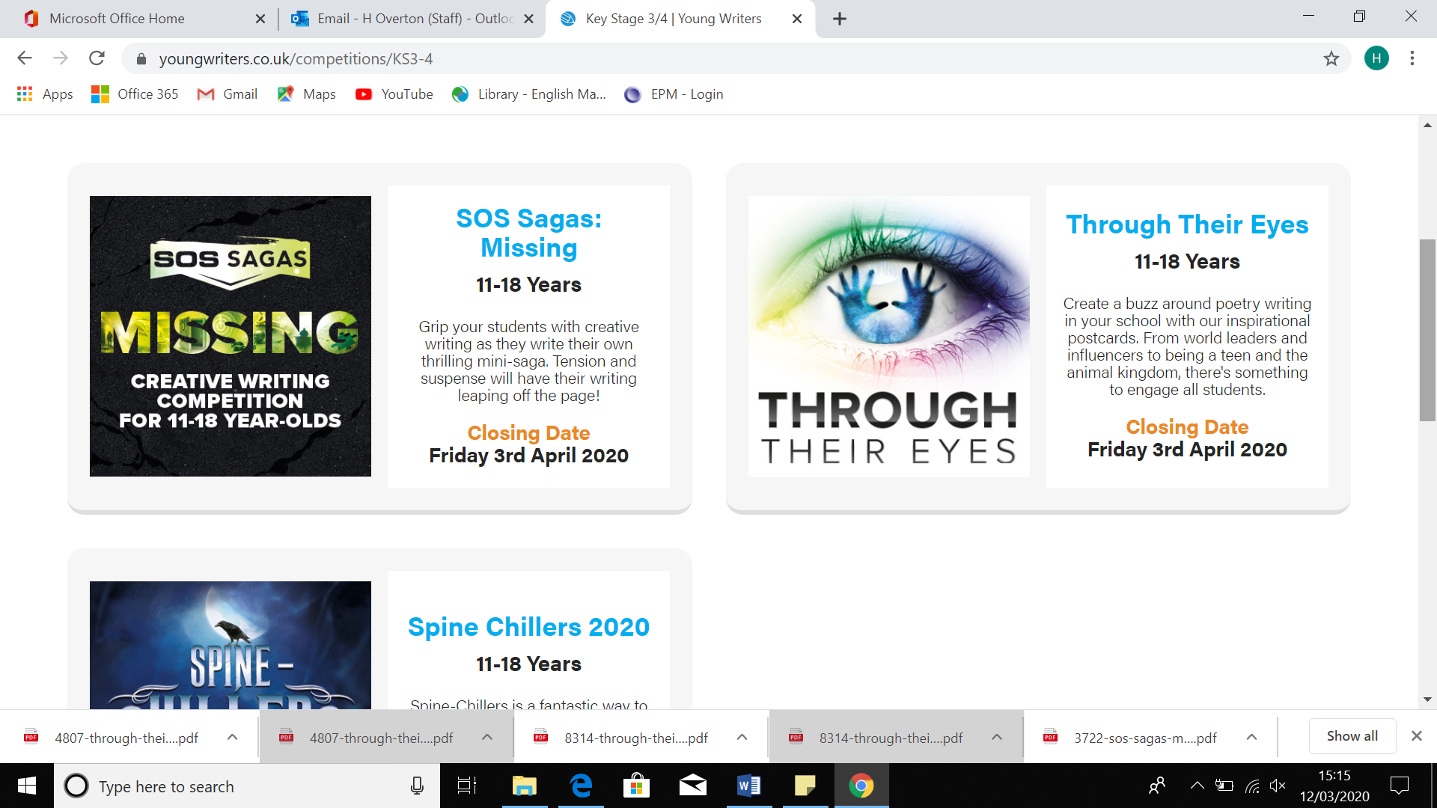
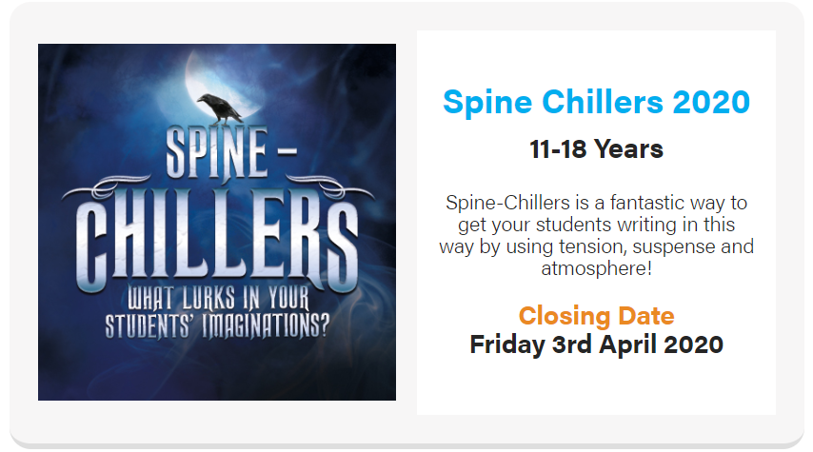
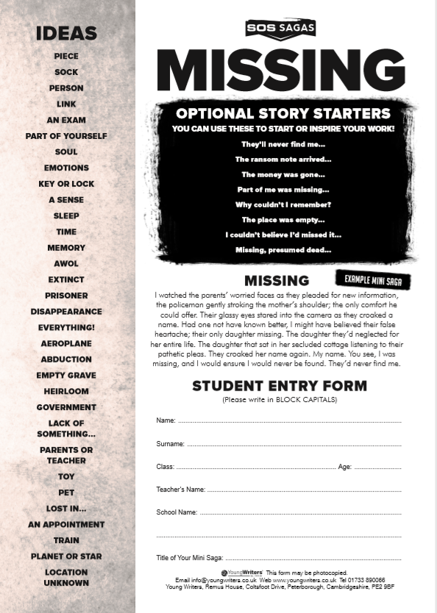

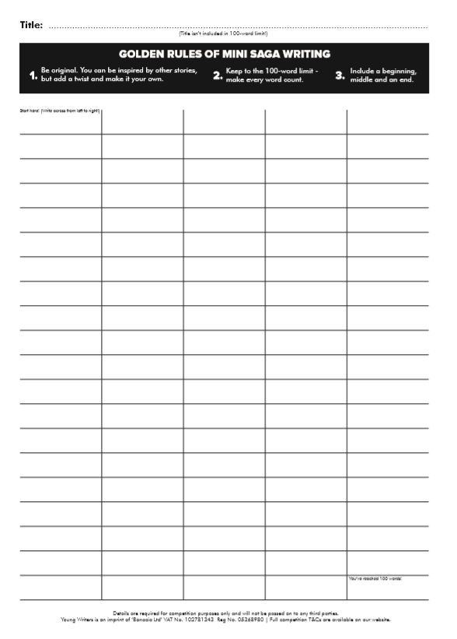
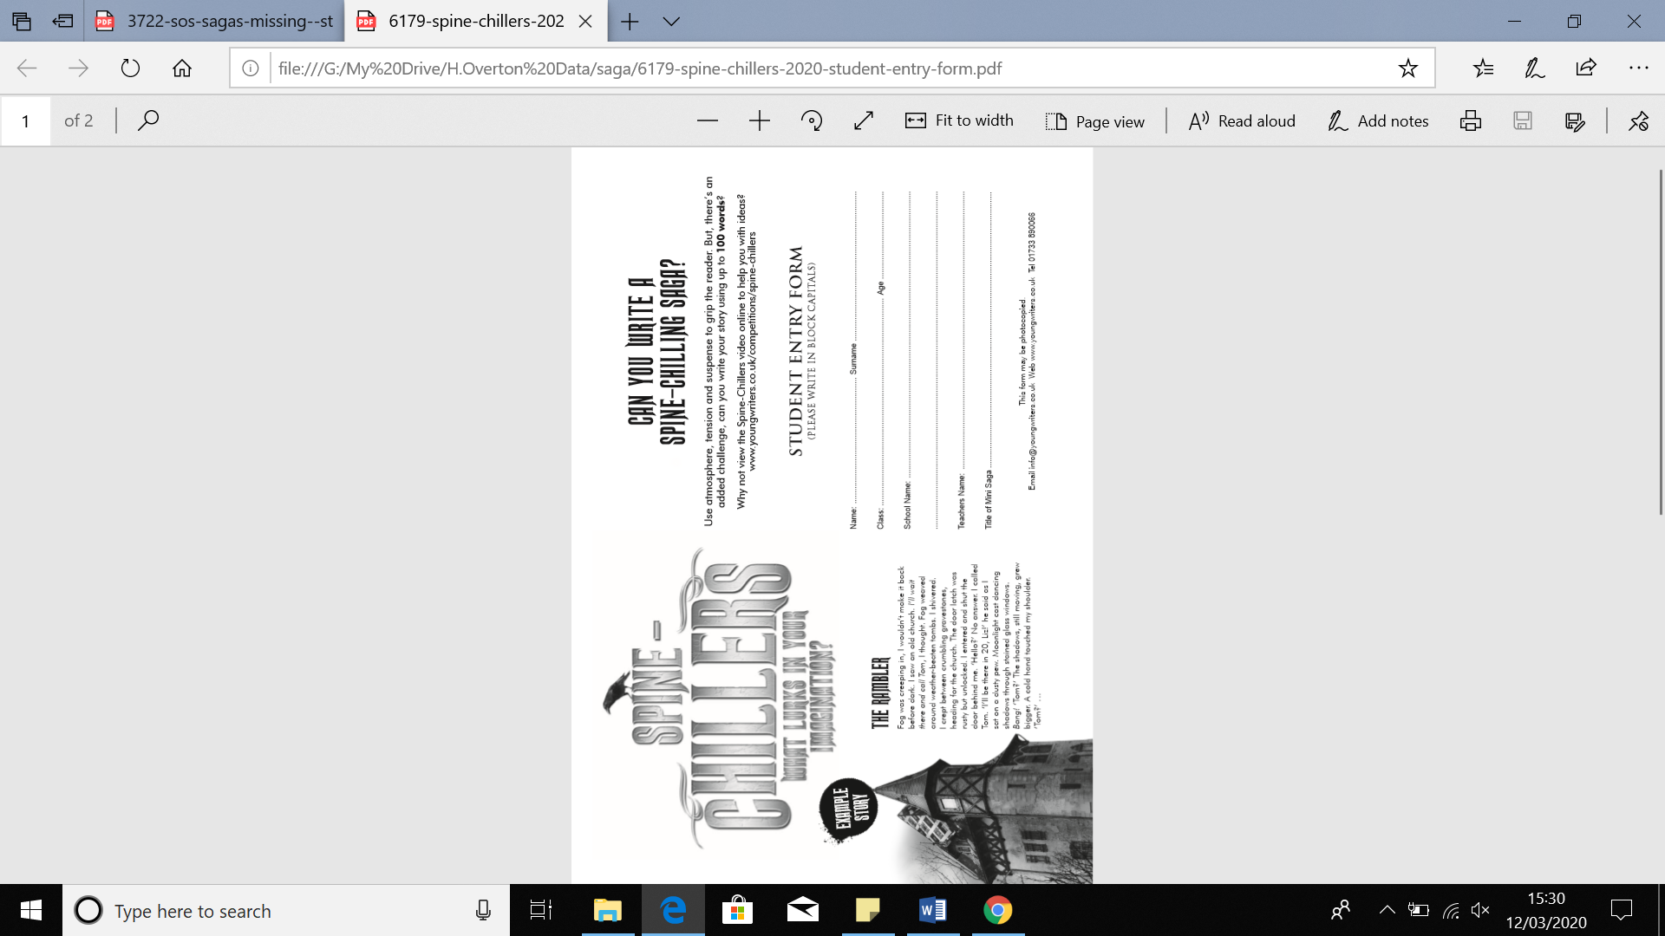
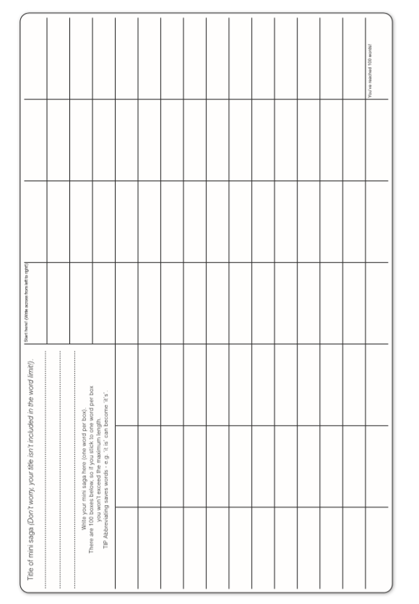
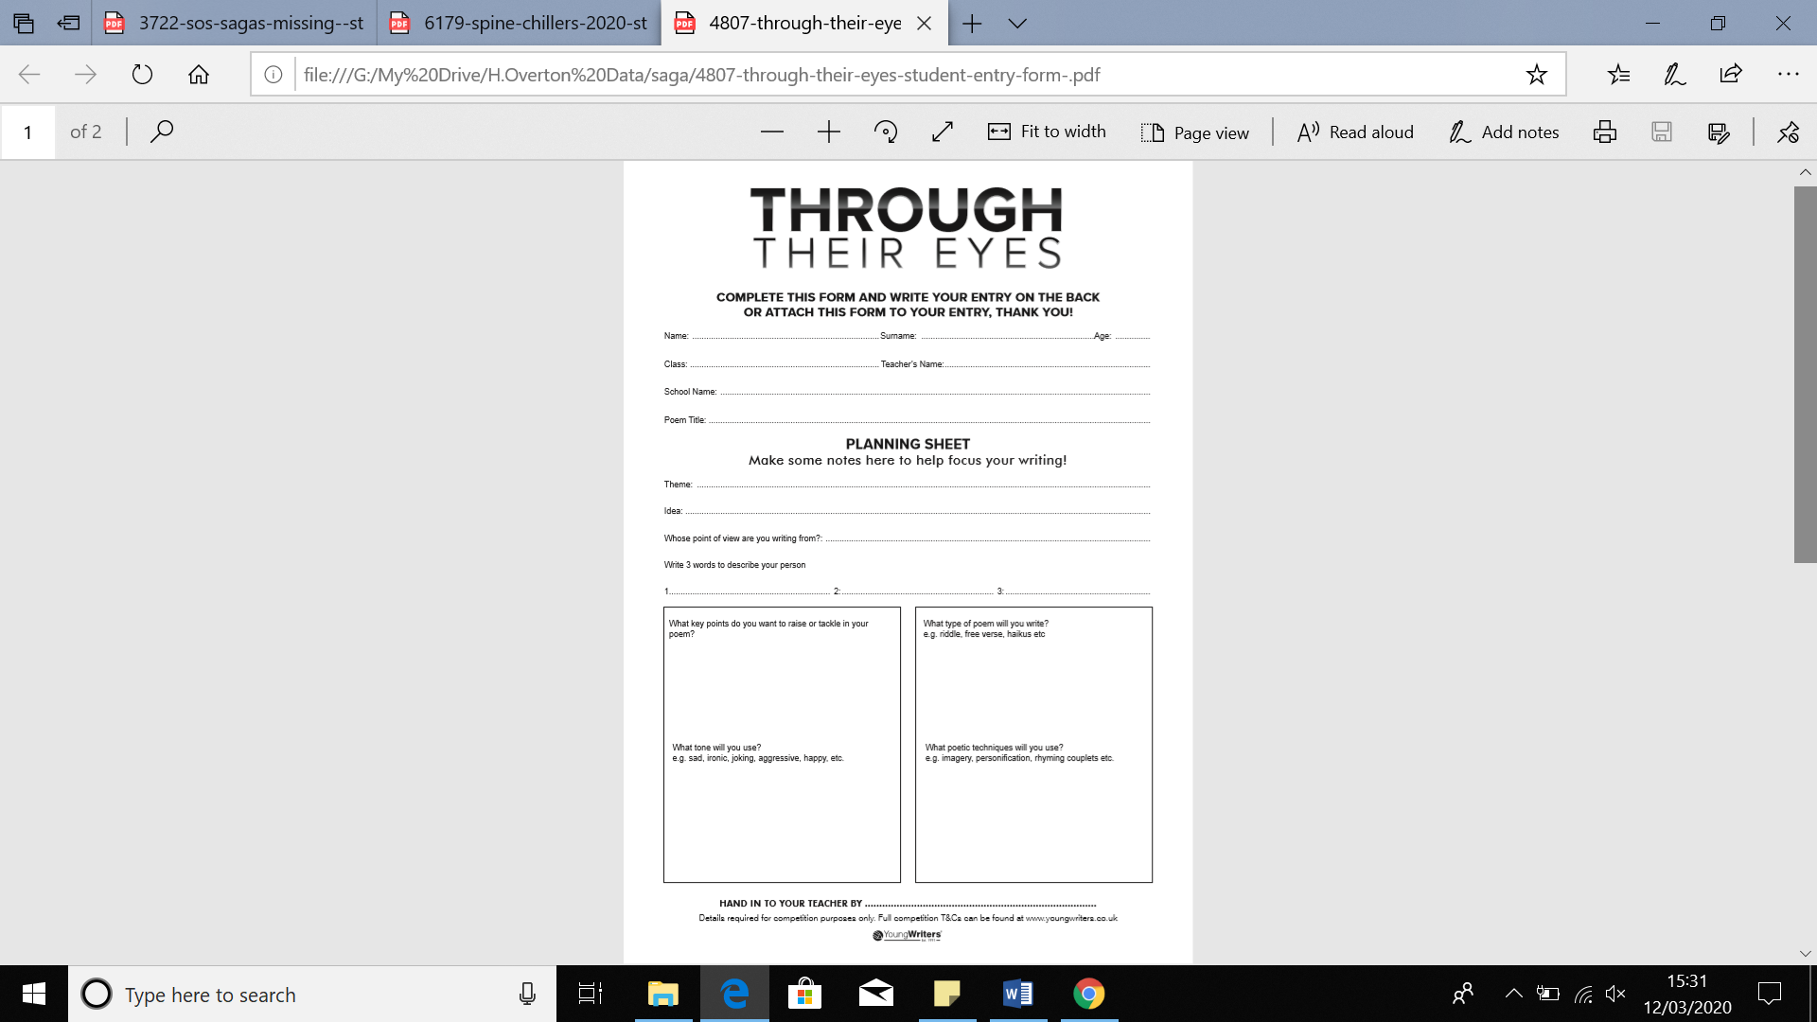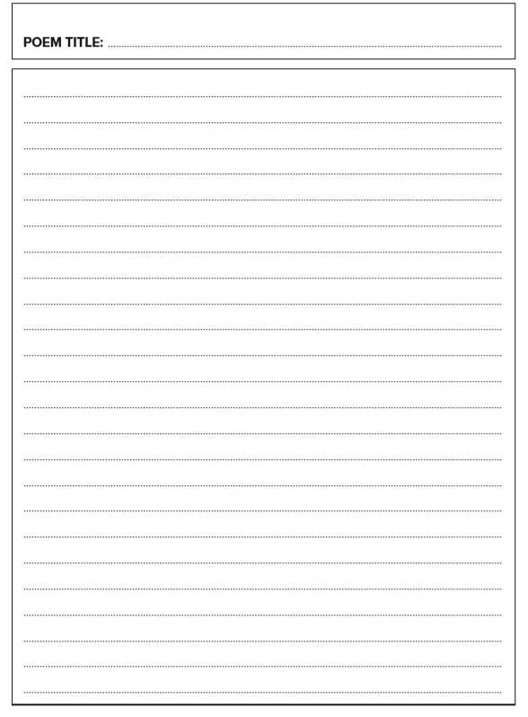

KS3 Home Learning Project

Online Learning and login details

Maths Watch Login Details…
GCSE Pod Login details…

